1.

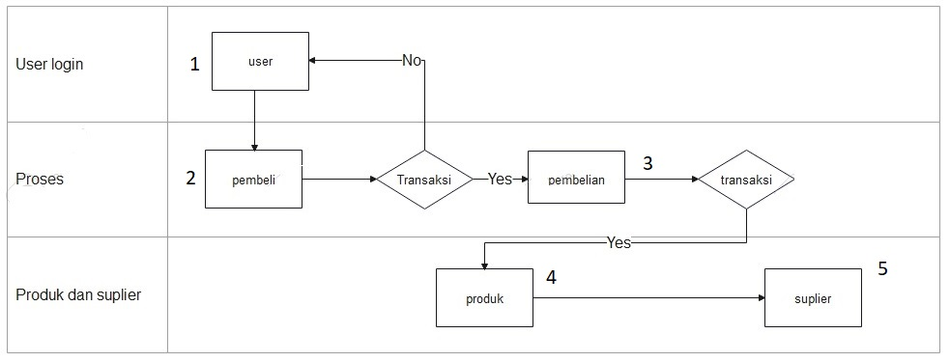

|  |  |
| --- | --- |
| **Entitas** | **Atribut** |
| users | id int  full_name varchar  created_at timestamp |
| pembelian.material | id int  material_code int  material_name varchar  material_type selection  material_qty float  material_buy_price float  related_suplier int  created_at varchar |
| product | id int  name varchar  merchant_id  price int  status  created_at datetime |
| suplier | id int  code_suplier int  name_suplier varchar  addres_suplier varchar  description_product varchar  created_at varchar |

2.

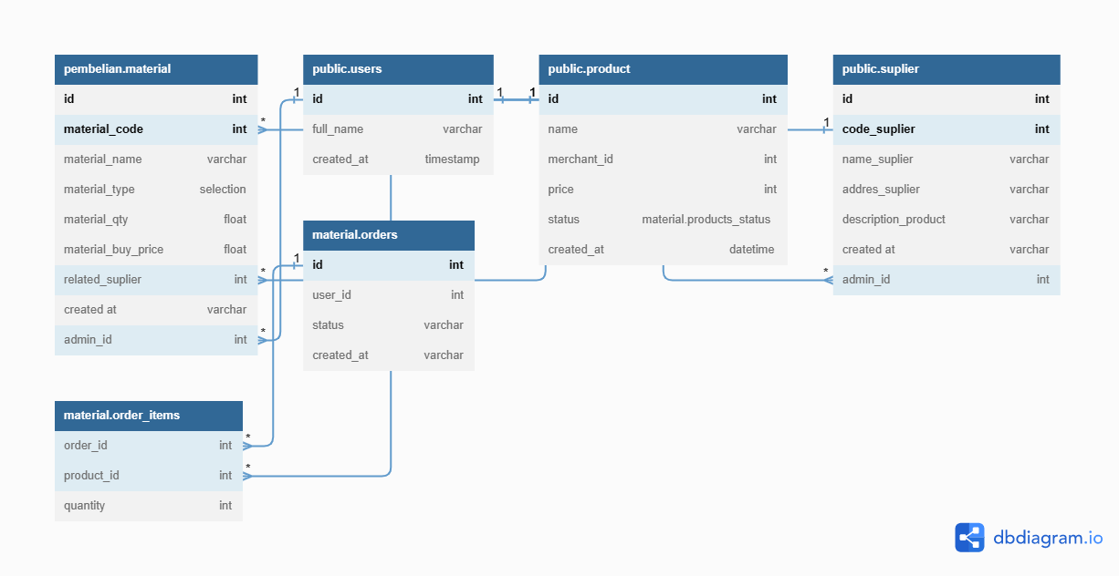

3.

**//// -- LEVEL 1**

Table pembelian.material {

id int

material_code int

material_name varchar

material_type selection

material_qty float

material_buy_price float

related_suplier int

"created at" varchar

admin_id int [ref: > U.id]

Indexes {

(id, material_code) [pk]

}

}

Ref: pembelian.material.material_code > product.id // many-to-one

Ref: pembelian.material.related_suplier > suplier.code_suplier

Table users as U {

id int [pk, increment] // auto-increment

full_name varchar

created_at timestamp

}

**//// -- LEVEL int2**

Table product {

id int [pk]

name varchar

merchant_id int [not null]

price int

status material.products_status

created_at datetime [default: `now()`]

Indexes {

(merchant_id, status) [name:'product_status']

id [unique]

}

}

Table suplier {

id int

code_suplier int [pk]

name_suplier varchar

addres_suplier varchar

description_product varchar

"created at" varchar

admin_id int [ref: > U.id]

Indexes {

(id, code_suplier) [pk]

}

}

Table material.order_items {

order_id int [ref: > material.orders.id] // inline relationship (many-to-one)

product_id int

quantity int [default: 1] // default value

}

Ref: material.order_items.product_id > product.id

Table material.orders {

id int [pk] // primary key

user_id int [not null, unique]

status varchar

created_at varchar [note: 'When order created'] // add column note

}

**//// -- LEVEL int3**

Enum material.products_status {

out_of_stock

in_stock

running_low [note: 'less than 100'] // add column note

}

4.

|  |  |  |  |  |  |
| --- | --- | --- | --- | --- | --- |
| No | No jalur | Data imput | Hasil yang diharapkan | Hasil pengujian | status |
| 1 | 1-2-3-4-5 | Material code  Material name  Material type  Material quantity  Material harga  Material suplier | Diharapkan user dapat melakukan pembelian material dimana data product dan supiler terdaftar di dalam database | User dapat melakukan pembelian material dengan memilih produk dang supplier yang sesuai | valid |
| 2 | 1-2-3-4-5 | Material code  Material name  Material type  Material quantity  Material harga  Material suplier | Diharapkan dapat menampilkan hasil dari pembelian material yang dilakukan | User dapat melihat pembelian yang dilakukan | valid |
| 3 | 1-2-3-4-5 | Material code  Material name  Material type  Material quantity  Material harga  Material suplier | Diharapkan user dapat melaukan update data pembelian | User dapat melakukan update pembelian | valid |
| 4 | 1-2-3-4-5 | Material code  Material name  Material type  Material quantity  Material harga  Material suplier | Diharapkan user dapat menghapus data pembelian yang dibatalkan | User dapat melakukan penghapusan data pembelian | valid |
| 5 | 1-2-3-4-5 | Material code  Material name  Material type  Material quantity  Material harga  Material suplier | Diharapkn dalam melakukan proses pembelian semua informasi harus terisi (mandatory)dan nilai price harus melebihi 100 | Dapat terisi semua kolom, alert price juga muncul jika nilainya < 100 | valid |